**RKT COLLEGE UNIT TEST DATE: __/__/2024**

**INFORMATION AND NETWORK SECURITY T.Y. BSc.IT SEM-V MARKS: 20**

1. Explain various principles of security.
2. Difference between Active attack and passive attack.
3. List and explain different categories of security services.
4. List and explain different categories of Security Mechanisms.
5. State any four Virus Countermeasures.
6. List and Explain the basic approaches of Cryptography are Substitution

and Transposition Techniques.

1. Define the following terms: -
   * + - * Brute force attack
         * Cryptanalysis
2. Explain Playfair Cipher Encrypt the plain text “SECRET MESSAGE” by
3. using keyword “PROBLEM”.
4. Difference between Symmetric key cryptography and Asymmetric

key cryptography.

1. Difference between Stream Cipher and Block Cipher.
2. Explain different types of algorithm modes in details.
3. Explain the working of DES Algorithm.
4. State the working of RSA algorithm?
5. Differentiate between Public Key Cryptography and Private Key Cryptography.
6. Using RSA algorithm, find the value of cipher text C, if the plaintext M = 5,

p = 3, q = 11, d = 7.

1. Differentiate between Symmetric Key encryption and Asymmetric

Key encryption.

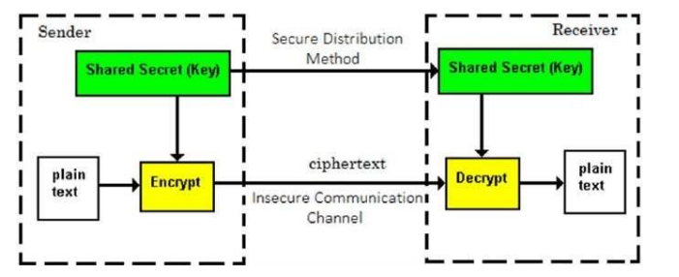

????

????

1. Elaborate Digital Signature Standard with its Algorithm.
2. Difference between Pretty Good Privacy and S/Mime
3. How can Pretty Good Privacy ensure Email security?



